FoodCorps: A Progress Report

Five years ago, FoodCorps set out to solve one of the most critical issues of our time: the broken relationship between America’s children and their food. We recognized that our country is raising a generation of children that is overweight and vulnerable to diet-related disease, and that a healthy diet is a fundamental building block for education, opportunity, and economic vitality. Yet inequities in our country and deficits in our food system have resulted in children receiving insufficient opportunities to learn about, access, and benefit from healthy food.

As the first national service organization to tackle the problems of healthy food education and access at scale, FoodCorps forged local and national partnerships, developed a framework, and placed a pioneering class of 50 corps members in community organizations across 10 states. Our young founding team approached this work with a confidence that big change is possible.

Today, we are faced with unprecedented political and social uncertainty. Several truths, however, remain very clear:
- 15 million children live below the poverty level. More than 30 million children participate in the National School Lunch Program and more than 12 million participate in the School Breakfast Program.
- Many children spend half their waking hours at school and consume as much as 50 percent of their daily calories there.
- The low-income students and students of color who face elevated risk of diet-related disease eat more meals at school than their white and affluent counterparts, heightening the importance of these institutions for kids who are too often held back.
- Schools are increasingly relied on to provide students with core nutrition and to teach lifelong habits around eating.
- Big change is needed—and big things are still possible.

There is no question: the coming year will bring many hurdles. With our steadfast supporters by our side, FoodCorps has the plan, the dedicated team, and the proven strategies to rise to these challenges.

We’re eager to share with you a preview of our work ahead. Together, we will ensure that that every school has the tools, knowledge, and desire to be a healthy school and that every child has the opportunity to lead a healthy, long, and fulfilling life.

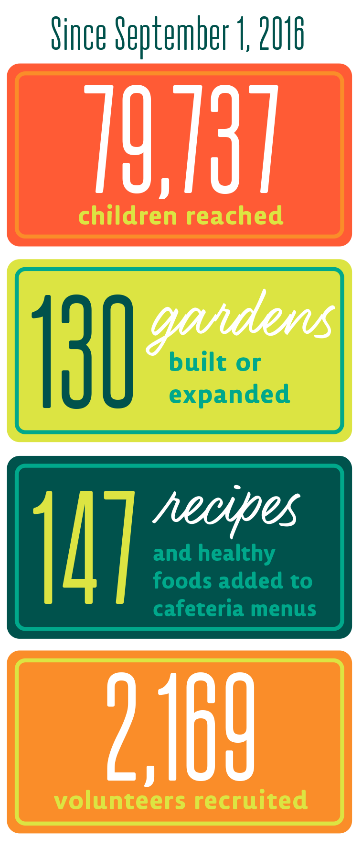
Growing Healthy Schools
Our nation has seven times as many school cafeterias as it does McDonald’s franchises, and schools teach our children—through both classroom instruction and culture—much of what they learn about food. Simply put, schools are the place to reverse the troubling health challenges that so many of our children face, so we must equip them to make meaningful, lasting changes.

That’s where FoodCorps comes in. Through our partnership with AmeriCorps, we recruit, train, and place emerging leaders in under-resourced schools to ensure every child we serve—regardless of race, class, or place—has the opportunity to grow up healthy and reach their full potential. Working alongside school administrators, educators, and food service staff, and engaging students, parents, and community volunteers, our corps members are implementing three evidence-based strategies that get kids eating healthy:

- Hands-on learning: Students have regular opportunities to grow, cook, and taste healthy foods, enabling them to learn about nutrition, build their skills, and improve their food preferences.
- Healthy school meals: The cafeteria, from what is served to how the lunch-line is laid out, steers students toward the healthiest options and gets them excited to try new healthy foods.
- Schoolwide culture of health: The whole school community—from teachers to principals to students to parents to staff—celebrates nutritious food and inspires healthy habits.

This year, FoodCorps is serving deeply in 350 schools across 18 states, connecting vulnerable children to healthy food and healthier futures. Our corps members help schools improve their programming and priorities to become places where children learn what healthy food is, fall in love with it, and eat it every day.

Change is happening in every school we serve. As corps member Jennifer Coverdale, now in her second service year in Lynn, Massachusetts, shared earlier this year:
“The principal was telling me about how hesitant she was to get students out into the garden at the beginning of the year, since she had such a strong emphasis on ‘time on task’ and wasn't sure how the garden programming would go. Once she saw the kids so happy and excited about planting and harvesting, she immediately wanted the whole school on board—not just the third and fifth grades as we had originally planned. She has so much buy-in to FoodCorps at this point that she was suggesting new ways to integrate the garden for taste tests and getting the kids eating healthy! She also mentioned that she was thinking about cutting the UMass nutrition program at the school, but after seeing how positively the kids responded to nutrition lessons taught through the garden, she decided to keep the program as part of the curriculum. I'm so excited to keep working with this school community; I can sense momentum for some big things to happen next year!”

The FoodCorps approach works. The schools we serve are becoming measurably healthier, and these changes are positively influencing children’s attitudes and behaviors toward healthy eating.
We’re proud to deliver an evidence-based program, but the kids themselves often describe our impact better than numbers can:
“Lunch is okay, but we
REALLY need more spinach.”
—Second grader in Georgia

"I learned to love lettuce
because of you guys!"
—Fourth grader
in Massachusetts
"Could you remind me the vegetables
I tried so I can tell my mom later?"
—Kindergartener after tasting
locally grown beets, broccoli, and kale

Evolving Our Program
FoodCorps students aren’t the only ones trying new things. As an ever-evolving organization built on collaboration and learning, we’re shaping our program to respond to opportunities and pressing needs in real time, as they arise.

Addressing the Lead Crisis in Flint, MI: In response to the devastating water-poisoning crisis in Flint, Michigan, FoodCorps expanded our five-year presence in the city threefold this fall—a request that came directly from the community. At a meeting with local leaders, Bill Basl, the head of AmeriCorps, asked what the people of Flint most wanted from AmeriCorps. Among their responses: "We want a FoodCorps member in every school.”

Today, our expanded cohort of six locally recruited corps members is doing just that, serving all 5,600 students at Flint Community Schools. In a city that has struggled with unreliable access to healthy food, FoodCorps enables Flint students to make healthy choices every day. While we cannot reverse the effects of lead exposure, we can help mitigate the impacts by ensuring kids exposed to unsafe levels of lead have access to restorative nutrition—one of the only proven ways to mitigate lead uptake in kids’ bodies..

Expanding Food Education Beyond School Hours: FoodCorps partnered with garden education experts at Life Lab to develop and launch a new after-school learning program that our service members are introducing in their communities nationwide. Modeled after skills-based programs like Girls Scouts and 4-H, FoodCorps’ new Sprout Scouts program is a gardening and cooking club that engages elementary-age students in developing life skills around growing, cooking, and eating healthy food.

Amplifying Our Impact and Influence: We’re working toward systems-level change that will impact children in schools beyond where our corps leaders serve directly. To that end, we opened our first state field office, in Connecticut. With the leadership of two senior staff members, we were able to expand our Connecticut service corps to 20 corps members—our largest state cohort to date—meaning we’re now reaching more children at greater depth. Along with administering top-notch FoodCorps programming, our field staff has forged partnerships with food service directors to institute district-level changes in school nutrition, and catalyzed the launch of statewide initiatives like Put Local On Your Tray, which helps Connecticut schools source and celebrate local food.

We see big possibilities with this enhanced on-the-ground presence, which is why, in 2017 we are launching field offices in Arizona, California, and Massachusetts. This next-phase strategy will help us drive more impactful programming in individual schools, while growing our influence as we cultivate vital relationships at all levels—from the schoolhouse to the state house—with the goal of driving policy reform that benefits schools, and children, beyond our direct reach.
Cultivating a Generation of Leaders
Every year, some 1,000 emerging leaders around the country answer the call to service in FoodCorps. We only have the resources to accept a small fraction of these new public servants into our program—215 this year. John Gomperts, FoodCorps board member and former AmeriCorps Director, recently said that what stands out most about FoodCorps as a national service program is our commitment to empowering service members and developing them as leaders.

FoodCorps invests in promising individuals who return that investment over a lifetime. We’re proud to share:

- More than 1 in 5 alumni have been hired by the FoodCorps school or community partner they served with—often in newly created positions that institutionalize the changes our program catalyzes.
- More than two-thirds of our alumni say FoodCorps connections and resources helped them get a job.
- 70% of FoodCorps alumni work in the nonprofit or public sectors, continuing their commitment to the public good.

Our most recently graduated alumni are now working in related fields as farmers, community organizers, and educators—like Miya Nixon. A Washington D.C. native, Miya (pictured, right) served with FoodCorps for the past two years with D.C. Greens at the Walker Jones Education Campus. This summer, following her service, Miya was hired by her school as a garden teacher and education aide.

“FoodCorps gave me the training and platform I needed to connect my interests, skills, beliefs, and goals, and gave me the confidence to serve my community for years to come.” — Miya Nixon, FoodCorps alumna (2014–16)

Through their careers and their advocacy, our 400+ alumni are a living, breathing testament to our success. We’re inspired by their commitment to making every school a healthy school, with many advancing into increasingly influential roles, such as district-level school food service directors and policy specialists with agencies like the USDA, where five FoodCorps alumni are currently on staff.

We are betting on these passionate leaders just as we are betting on the children they serve. They are the stewards who will carry out our shared vision for a healthier future for all children.

The very students we serve in the classroom are becoming leaders in their own right. We’re proud to name at least one among our ranks: Julia Paige, who experienced the power of FoodCorps firsthand as a student during our inaugural year of programming. Julia is now serving in her hometown of Traverse City, Michigan, fostering the next generation of leaders, stewards, and advocates for healthier schools and healthier kids. We can’t wait to see who she inspires to lead and serve.
Our Commitment to Equity, Diversity & Inclusion: As important as what’s on our children’s plates is who is at the table. The dynamics of public service and the demographics of the food movement have created an unacceptable gap in our leadership pipeline. With the same conviction that we hold for serving our nation’s most marginalized children, we recognize the critical importance of recruiting and cultivating a racially and economically diverse generation of leaders from within the communities we serve—those best positioned to catalyze local change and more likely to continue contributing to these communities after their service ends. We’re proud to report our application pool and our service corps have shown exciting improvements toward these efforts with each passing year. Among our current cohort, one third of service members are leaders of color, and more than 80% are serving in the state they call home.

A National Vision for Healthy Schools
Every school should be a healthy school, and every child deserves the chance to grow up healthy. Knowing we cannot place a FoodCorps member in all 100,000 public schools across the country, we’re committed to effecting change through policy initiatives at the local, state, and national level, so as to benefit all our nation’s schools and their students for generations to come.

Our success relies on evidence and advocacy. Through our service program, FoodCorps is building a national proof point of data that will demonstrate the value of healthy schools to policymakers and other leaders, inspiring reforms that can make our proven program the norm nationwide. We’re also building an aligned action network—with our 170 community partners, our 400+ alumni, the 350 schools we serve, and the national coalitions we’ve joined—to advocate for these reforms. Together, we are uniting behind a common goal and speaking with a unified voice to achieve our vision for a nation of healthy schools.

FoodCorps has earned the respect of policymakers, from community representatives to state houses to the halls of Congress. This year, we’re positioning FoodCorps strategically to drive change in multi-level policy conversations, by increasing our investment in policy initiatives at the local and state levels and fostering bipartisan support in the Congressional districts we serve. We’re actively hiring for a D.C.-based Policy Director, who will guide our work, state by state, to achieve policy wins in and around the communities we serve, while leading the development of a national FoodCorps policy platform in support of child nutrition.

________________________________

In these times of uncertainty, the power of our collective achievements and the energy of our shared momentum are what carry us forward.

The audacious work of systemic change begins in the individual schools we serve, every day. As a corps member serving in Muskegon, Michigan, heard a middle school student say in the wake of this fall’s election: "We might not be able to change the world right away, but we can change our school."

Your leadership, support, and inspiration bring us closer, every day, school by school, toward our vision for a healthier future for all children.

We thank you and look forward to your ongoing partnership.

